CSA15 Cloud Computing and Big Data Analytics Local IaaS Lab: Type-2 Hypervisor Installation and First Linux Virtual Machine
Course Code | CSA15 | Course Title | Cloud Computing and Big Data  Analytics
Guided Project | GP-VM-01 | Submission | Individual evidence through GitHub and Google Classroom
Faculty | Dr C. Rajesh Babu | Employee ID | SSETSCS415
Target Learner | Beginner CSE student | Estimated  Duration | 3 to 4 lab hours
Primary Tool | Oracle VirtualBox or VMware  Workstation + selected Linux ISO | Cloud Link | Models the local foundation of IaaS before public-cloud VM provisioning
Guided Project Pattern
Read the idea, perform the action, observe the result, record evidence, explain what happened, extend the setup to your capstone context, and submit the final proof through GitHub and Google Classroom.

Learning Outcomes
- Install either Oracle VirtualBox or VMware Workstation as a type-2 hypervisor.
- Select a guest operating system according to download size, laptop capacity and lab time.
- Create and configure a VM with CPU, RAM, virtual disk, storage controller and NAT network.
- Boot or install the selected guest OS and verify CPU, memory, storage and network evidence.
- Submit an individual evidence portfolio through GitHub and Google Classroom.
Before You Start
- Windows/macOS/Linux laptop with virtualization enabled in BIOS/UEFI or system settings.
- Minimum 8 GB host RAM recommended; keep at least 25 GB free disk space when using Ubuntu and at least 8 GB when using Tiny Core/Alpine.
- Administrator permission to install the hypervisor and its network drivers.
- One selected hypervisor and one selected guest OS image from the tables below.
- GitHub account and Google Classroom access.
Quick Learning Notes
- A host OS is the operating system already running on the laptop. A guest OS is the operating system running inside the VM. - A type-2 hypervisor runs above the host OS, so it is suitable for student laptops and lab demonstrations. - An ISO file behaves like a bootable installation DVD attached to the VM.
- NAT networking is preferred for this beginner lab because the guest VM can access the internet through the host without being directly exposed to the local network.
- The value 1 CPU, 2 GB RAM and 15 GB disk is the standard lab configuration; smaller OS images may safely use lower RAM/disk values if the student records the reason.
Lab Exercise Coverage
Lab Exercise | How This Guided Project Covers It
Experiment 7 | Install a type-2 hypervisor, create and configure a VM image with a selected guest operating system.
Experiment 8 | Create a VM with 1 CPU, 2 GB RAM and 15 GB storage disk, or record a justified lightweight-OS alternative.

Hypervisor Choice
Tool | When to Choose It | Student Evidence
Oracle VirtualBox | Choose when the laptop supports VirtualBox well, the student wants a free cross-platform tool, or VMware is not available. | VirtualBox version, New VM window, Settings screenshots and running guest OS proof.
VMware Workstation | Choose when VMware installer is available and the student wants to practice the lab-manual VMware workflow. | Installer file/version, VMware home screen, VM settings screenshots and running guest OS proof.

GP-VM-01 | CSA15 Cloud Computing and Big Data Analytics | Dr C. Rajesh Babu, SSETSCS415
Guest OS Selection Guide
Choose one guest operating system based on laptop capacity, internet bandwidth and lab time. Record the selected image name, approximate size and reason for selection before creating the VM.
Option | Approx. Size | Best Use | Official Download | Suggested VM Setting
Tiny Core Linux Core | About 17 MB | Fastest boot and very low-bandwidth VM  proof. | https://tinycorelinux.net/downloads.html | 1 CPU, 256 to 512 MB  RAM, 2 to 4 GB disk
Tiny Core Linux CorePlus | About 250 MB | Graphical desktop  practice with small  download size. | https://tinycorelinux.net/downloads.html | 1 CPU, 512 MB RAM, 4 GB disk
Alpine Linux  Standard | About 200 to 300  MB | Lightweight server-style Linux and package  practice. | https://alpinelinux.org/downloads/ | 1 CPU, 512 MB to 1 GB RAM, 4 to 8 GB disk
Debian netinst | About 700 to 800  MB | Minimal standard Linux installation with  optional packages. | https://www.debian.org/distrib/netinst | 1 CPU, 1 to 2 GB RAM, 8 to 15 GB disk
Ubuntu Server  LTS | About 3 to 4 GB | Full Linux server  practice when  bandwidth is available. | https://ubuntu.com/download/server | 1 CPU, 2 GB RAM, 15 GB disk
Ubuntu Desktop LTS | About 6 GB | Full desktop Linux  practice when  bandwidth and storage are available. | https://ubuntu.com/download/desktop | 1 CPU, 2 to 4 GB RAM, 20 GB disk
Safety Rule
Do not allocate all host resources to the VM. Use NAT networking unless instructed otherwise. Never select a physical host disk for guest installation; the installation must happen only inside the virtual disk.

Architecture View
Laptop  Hardware | Host OS | Selected Type-2  Hypervisor | Virtual Hardware | Guest OS ISO | Evidence

The laptop remains the physical resource provider. The selected hypervisor creates virtual CPU, RAM, disk and network devices. The selected Linux image becomes the guest operating system.
Guided Build
Stage 1 - Confirm Host Readiness
Learn: Virtualization support must be available before a VM can run reliably.
- Open Task Manager on Windows and check Performance -> CPU -> Virtualization. On macOS/Linux, use system information or terminal/system settings as available.
- Record host operating system, processor type, installed RAM and free disk space.
- Create a folder named CSA15_VM01_RegisterNumber on the host system.
- If virtualization is disabled, record the issue and enable it through BIOS/UEFI only with faculty or lab support.
Checkpoint
Host OS, RAM, free storage and virtualization status are recorded before downloading any installer.

Record 1 - Host readiness evidence
. Host OS: Windows 11
Processor: 12th Gen Intel(R) Core(TM) i5-1235U
Installed RAM: 16 GB (15.7 GB usable)
Free Disk Space: 30.4 GB free of 179 GB on Local Disk (C:)
Virtualization: Enabled
Observation: The host system has virtuaSlization enabled and sufficient CPU, memory and available disk resources to run the Type-2 hypervisor and the configured Linux virtual machine.

GP-VM-01 | CSA15 Cloud Computing and Big Data Analytics | Dr C. Rajesh Babu, SSETSCS415
Stage 2 - Download the Selected Hypervisor
Learn: The hypervisor is the software layer that creates and manages the virtual computer.
- If choosing VirtualBox, open https://www.virtualbox.org/wiki/Downloads and select the platform package matching the host OS, such as Windows hosts or macOS hosts.
- If choosing VMware Workstation, use the faculty-shared installer or the official VMware/Broadcom Workstation download page and choose the installer matching the host OS.
- Save the installer inside the project folder or Downloads folder.
- Record installer filename, source link, download date and approximate file size.
- Do not download installers from unofficial software mirrors.
Checkpoint
The selected hypervisor installer file is available and its source is recorded.

Record 2 - Hypervisor download evidence
Type your observation / paste screenshot / add GitHub evidence link here.
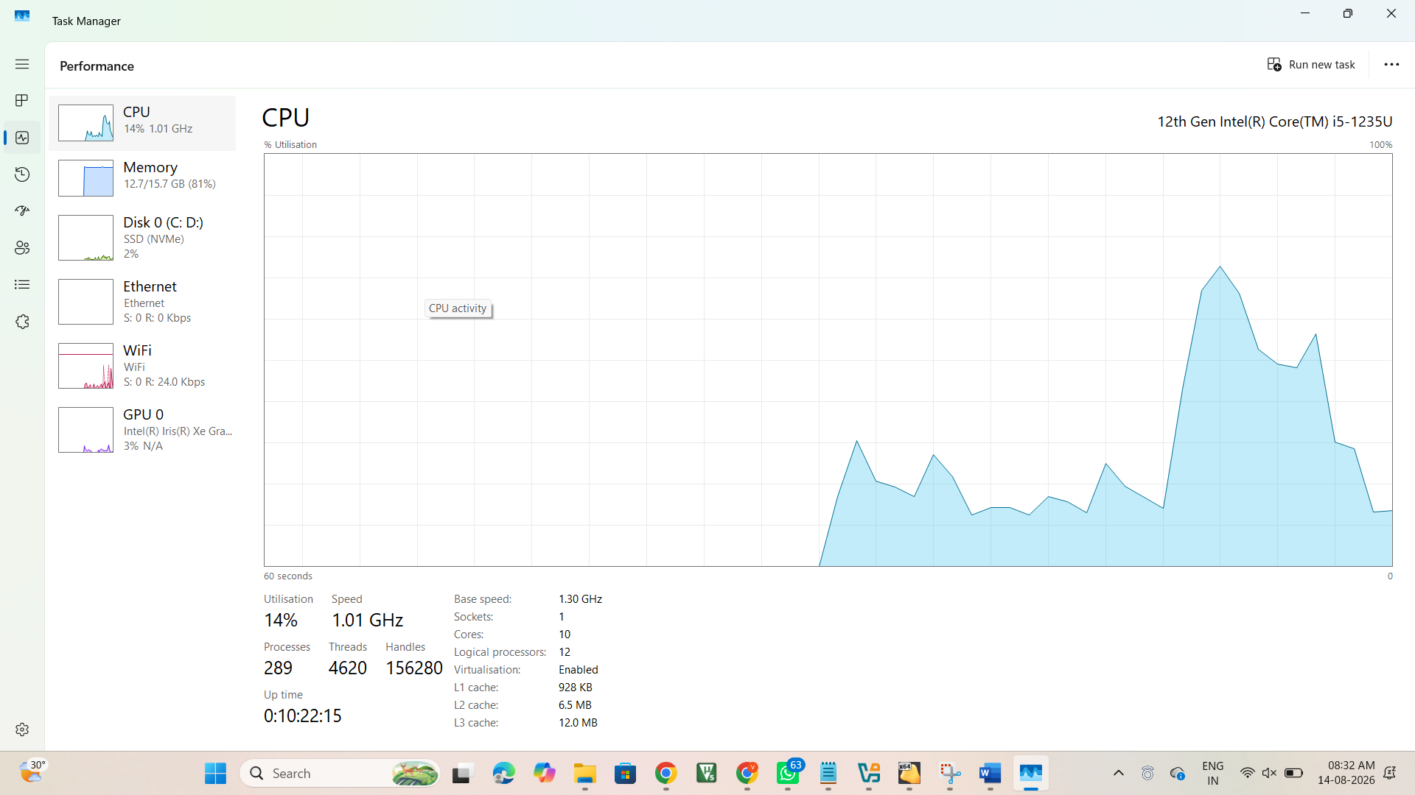

Stage 3 - Install the Hypervisor
Learn: During installation, the hypervisor adds drivers for virtual networking, USB integration and virtual hardware management.
- For VirtualBox, open the installer, proceed with default components, allow network interface installation when prompted, finish installation and open VirtualBox Manager.
- For VMware Workstation, open the installer, choose Typical setup, keep default installation path, allow network adapter installation, skip or disable optional customer-experience participation if shown, finish and reboot if requested.
- For VMware Workstation personal/free use prompts, select the free/non-commercial option when it is legally available for the installed edition.
- Open the installed application and capture the home screen or About screen.
- Record the exact installed version.
Checkpoint
The selected hypervisor opens successfully and the installed version is visible.

Record 3 - Hypervisor installation evidence
Selected Hypervisor: Oracle VirtualBox
Purpose: Type-2 hypervisor for creating and managing the Linux virtual machine.
Installer Source: Official Oracle VirtualBox download source
Installation Status: Installed and working successfully.
Evidence: VirtualBox Manager screenshot showing the configured csa15-localvm-192372057 VM and its clone.
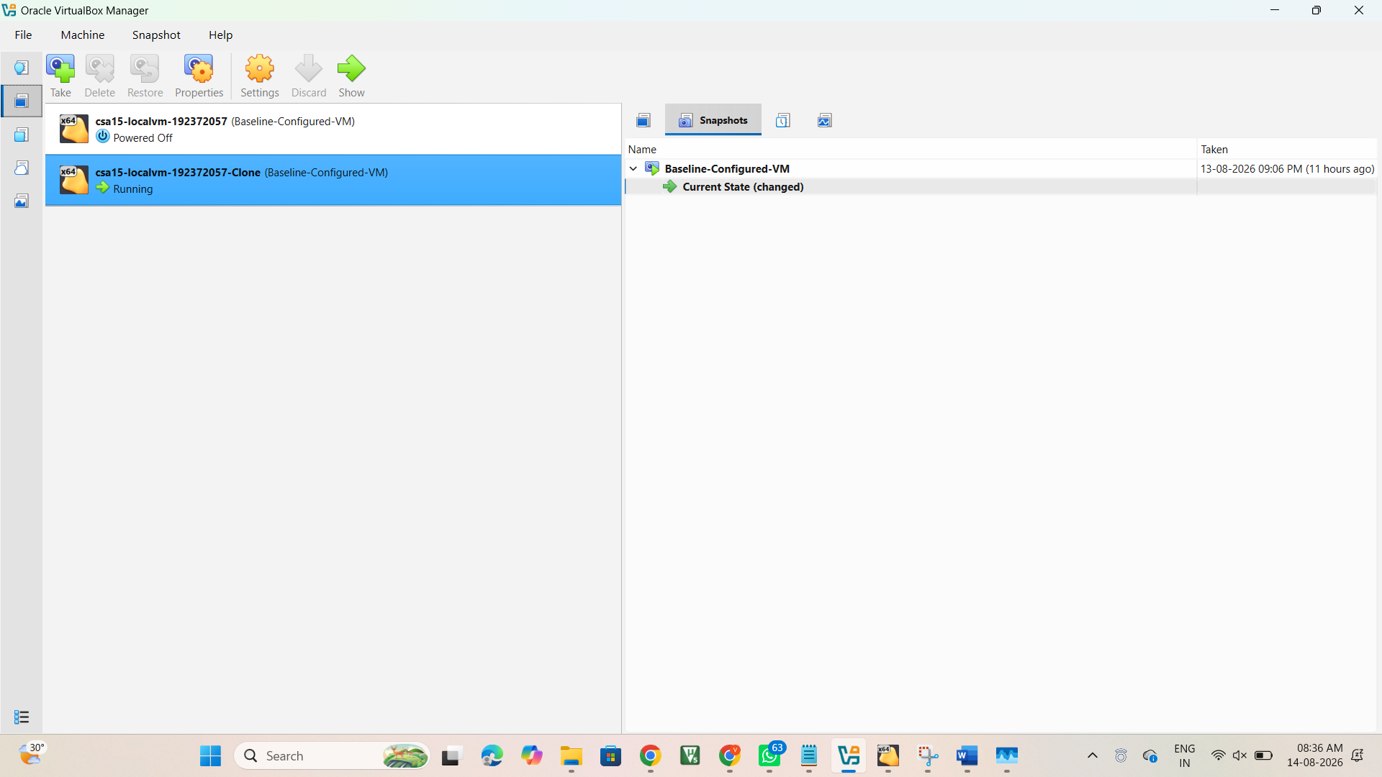
Selected Hypervisor: Oracle VirtualBox
Installer Filename: VirtualBox-7.2.14-174565-Win
Installer Type: Windows Application
Approximate File Size: 169 MB
Download Date: 07-08-2026
Source: Oracle VirtualBox official download page — https://www.virtualbox.org/wiki/Downloads
Observation: The Oracle VirtualBox installer was successfully downloaded and is available on the host system. The installer corresponds to the Windows host platform and was subsequently used to install and run VirtualBox.

Stage 4 - Choose and Download the Guest OS
Learn: The guest OS image controls download time, VM size and installation complexity.
- Study the Guest OS Selection Guide table.
- Choose Tiny Core, Alpine, Debian netinst, Ubuntu Server or Ubuntu Desktop according to laptop capacity and internet speed. - Download the ISO from the official link shown in the table.
- Record selected OS name, ISO filename, approximate download size and reason for choosing it.
- Keep the ISO file until the VM boots successfully and evidence is verified.
GP-VM-01 | CSA15 Cloud Computing and Big Data Analytics | Dr C. Rajesh Babu, SSETSCS415
Checkpoint
The selected guest OS ISO is ready and the selection reason is written clearly.

Record 4 - Guest OS selection evidence
Selected Guest OS: Tiny Core Linux CorePlus
ISO Filename: CorePlus-current
Approximate ISO Size: 282,624 KB (approximately 276 MB)
Official Source: Tiny Core Linux official download site
VM Configuration: 1 CPU, 512 MB RAM, 4 GB virtual disk
Reason for Selection: Tiny Core Linux CorePlus was selected because it is lightweight, has a relatively small download size, provides a graphical desktop environment, and is suitable for quick VM demonstration on a laptop with limited available disk space.

Stage 5 - Create the VM Shell
Learn: A VM shell is the empty virtual computer before the guest OS starts.
- In VirtualBox, click New. In VMware, choose Create a New Virtual Machine.
- Name the VM CSA15-SelectedOS-RegisterNumber.
- Choose Linux as the OS family and the closest matching version. Use Other Linux when the exact lightweight OS is not listed. - Store the VM inside a known folder, preferably CSA15_VM01_RegisterNumber.
- Attach the selected ISO during creation if the wizard allows it; otherwise attach it later through VM settings.
Checkpoint
The new VM appears in VirtualBox Manager or VMware Library with the correct name and OS family.

Record 5 - VM creation evidence
VM Name: csa15-localvm-192372057-Clone
OS Family: Linux
OS Distribution: Other Linux
OS Version: Other Linux (64-bit)
Installation ISO: CorePlus-current.iso
Virtual Disk: csa15-localvm-192372057-Clone.vdi
Storage Controller: SATA (AHCI)
Location: C:\Users\HP\VirtualBox VMs\csa15-localvm-192372057-Clone\csa15-localvm-192372057-Clone.vdi
Network: NAT
Observation: The VM was successfully created in Oracle VirtualBox with Linux selected as the guest operating system. The Tiny Core CorePlus ISO is attached through the IDE controller, and a VDI virtual disk is attached through the SATA controller. NAT networking is enabled.
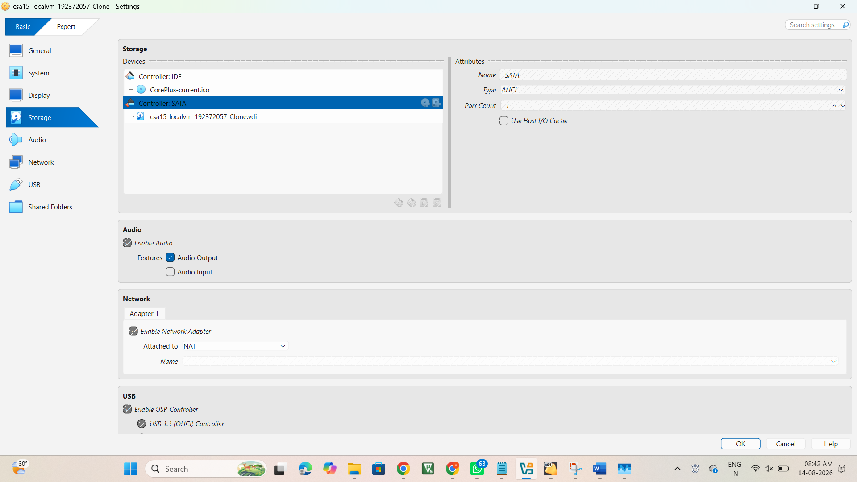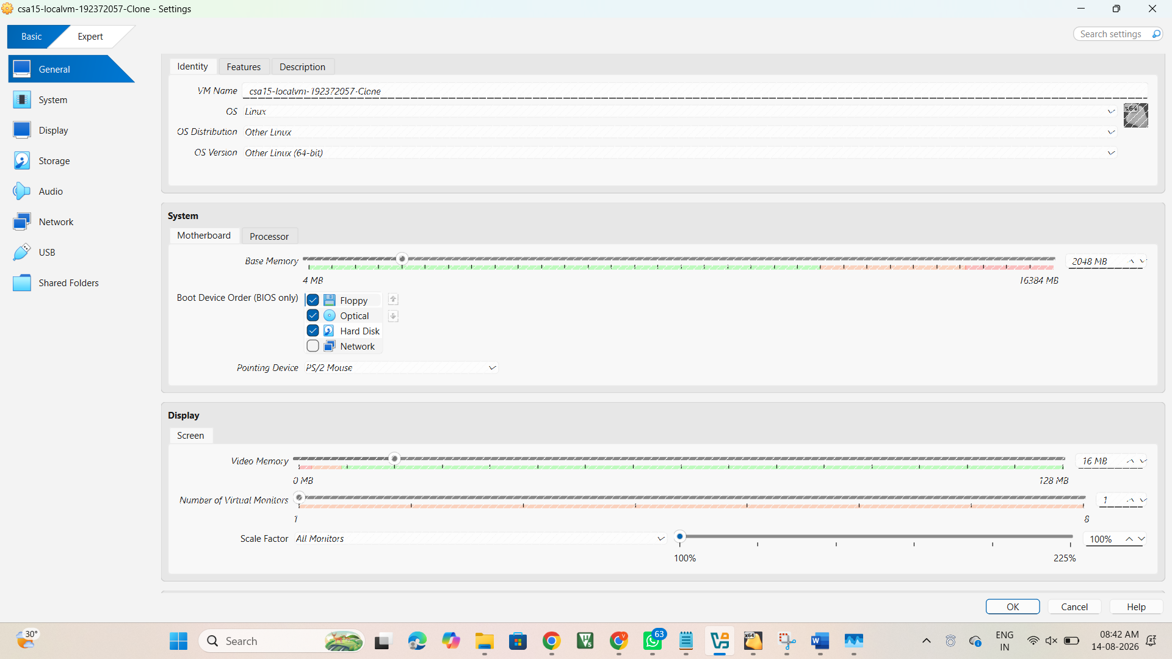

Stage 6 - Configure CPU, RAM, Disk and Network
Learn: CPU, RAM and disk values must be enough for the guest OS without damaging host performance. - Set CPU to 1 processor/core for the lab.
- Set RAM from the OS table. For the standard lab configuration use 2048 MB.
- Create a dynamically allocated disk. Use 15 GB for the standard lab configuration or the OS-table value for lightweight OS choices. - Use VDI for VirtualBox or VMDK for VMware unless the faculty specifies another disk format.
- Keep the network adapter as NAT.
- Open VM settings and capture CPU, RAM, disk and network screens before first boot.
Checkpoint
The VM settings show CPU, RAM, virtual disk size, disk format/controller and NAT network.

Record 6 - VM hardware configuration evidence
CPU: 2 CPUs
RAM: 2048 MB (2 GB)
Virtual Disk: 20 GB
Disk Format: Normal (VDI)
Disk Allocation: Dynamically allocated differencing storage
Storage Controller: SATA (AHCI)
Network Mode: NAT
ISO: CorePlus-current.iso
Observation: The virtual machine is configured with 2 virtual CPUs, 2 GB RAM, a 20 GB dynamically allocated VDI disk, SATA storage, and NAT networking. The CorePlus Linux ISO is attached for guest OS booting.
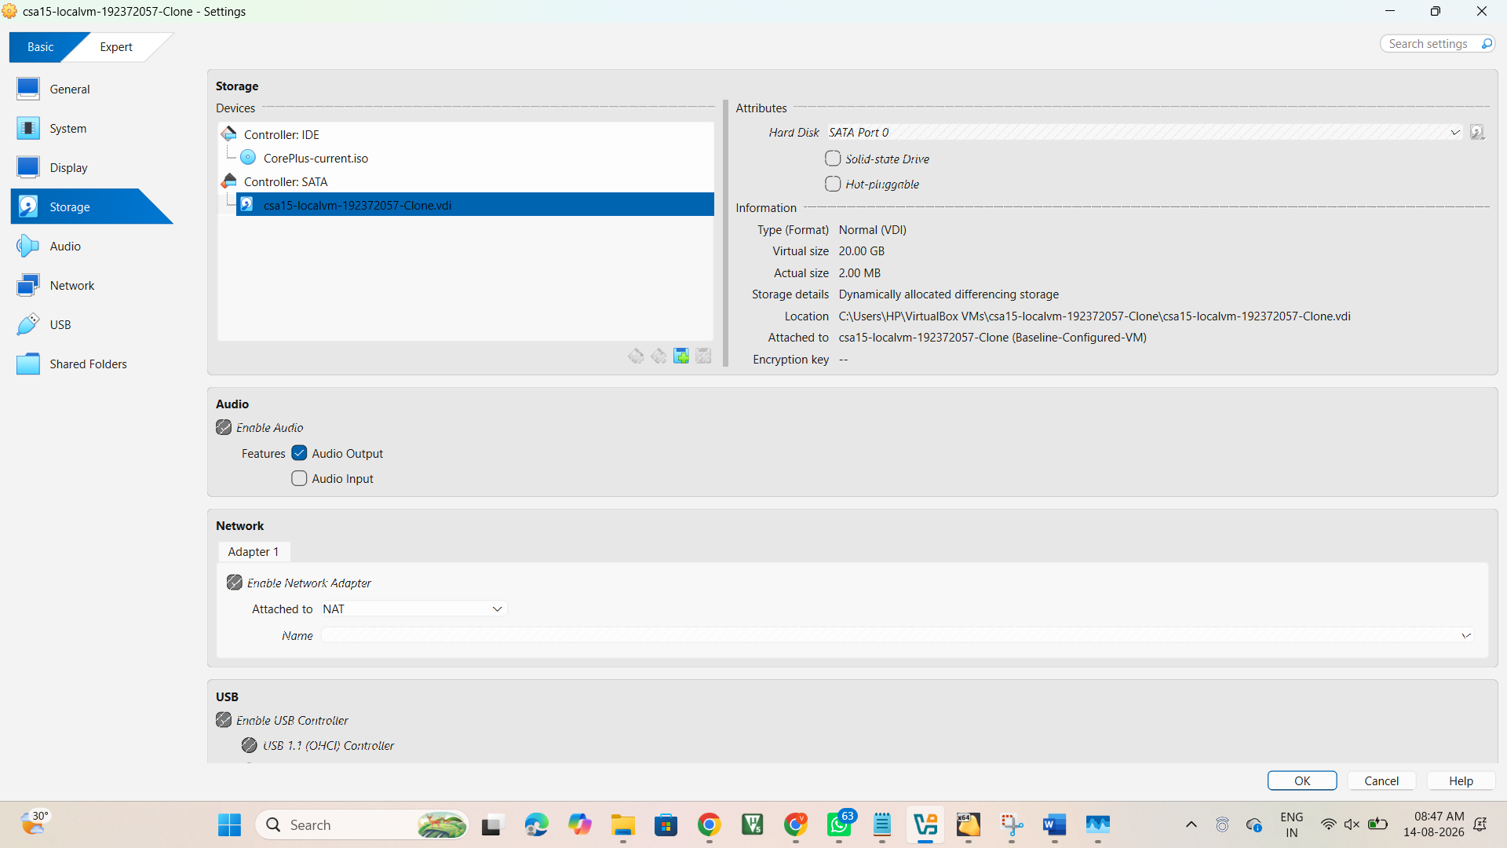
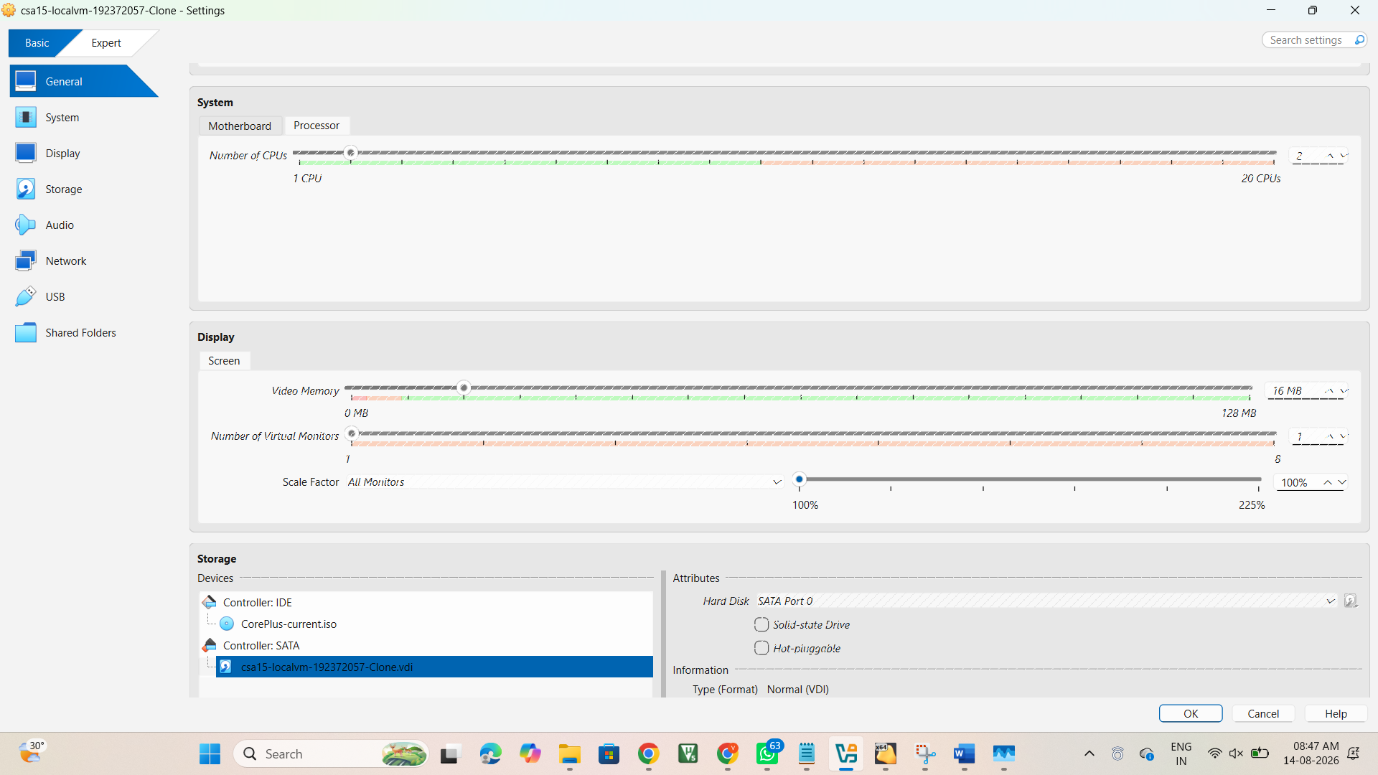

Stage 7 - Boot, Install or Run the Guest OS
Learn: The VM boots from the ISO first; after installation, it can boot from the virtual disk.
GP-VM-01 | CSA15 Cloud Computing and Big Data Analytics | Dr C. Rajesh Babu, SSETSCS415
- Start or Power On the VM.
- If the OS is Tiny Core, reach the live desktop and record the desktop proof.
- If the OS is Alpine or Debian, reach the installer or shell/login prompt and follow the minimal installation path if instructed. - If the OS is Ubuntu, choose Try/Install or Install Ubuntu according to lab time and faculty instruction. - When an installer asks about disk usage, choose the VM virtual disk only. It is safe to erase the VM disk; it must not refer to the host physical disk.
- After boot or installation, capture the guest OS screen.
Checkpoint
The selected guest OS boots inside the VM and the evidence clearly shows it is running within the hypervisor window.

Record 7 - Guest OS boot or installation evidence
VM Status: Running
Guest OS: Tiny Core Linux CorePlus
Hypervisor: Oracle VirtualBox
Boot Result: Guest OS successfully booted and reached the Tiny Core Linux desktop/shell.
Observation: The Linux guest operating system is running successfully inside the Oracle VirtualBox Type-2 hypervisor.

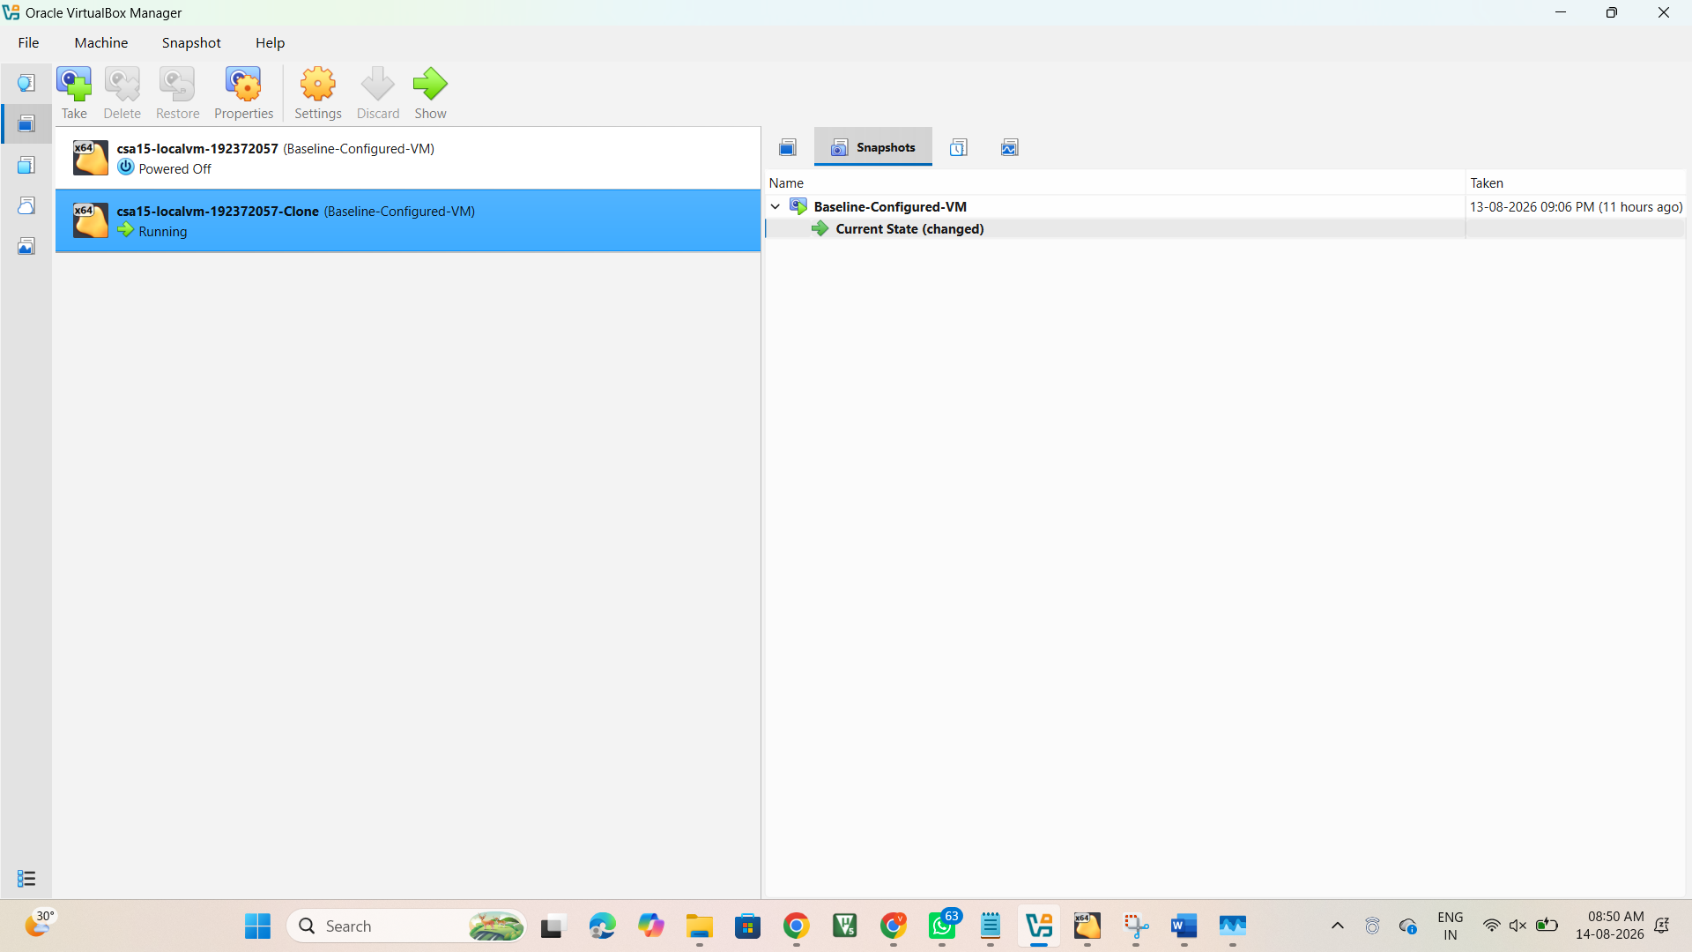

Stage 8 - Verify the VM from Inside the Guest OS
Learn: A configured VM is valid only when the guest OS can report its CPU, memory, storage and network state. - Open terminal, shell or console in the guest OS.
- Run lscpu if available; otherwise record CPU details from the guest system or hypervisor settings.
- Run free -h or cat /proc/meminfo to verify memory.
- Run df -h to verify mounted storage.
- Run ip addr, ifconfig or ping 1.1.1.1 to verify networking.
- Capture all command outputs in a readable screenshot.
Checkpoint
CPU, RAM, disk and network evidence is captured from the guest OS or justified with available alternatives.

Record 8 - Guest verification evidence
Guest OS: Tiny Core Linux 6.1.35-tinycore
CPU: 2 virtual CPUs configured in VirtualBox
RAM: 2.00 GB total
Storage: 1.8 GB root filesystem, approximately 1.7 GB available
Network: eth0 active with IP address 10.0.2.15
Network Mode: NAT
Observation: The guest operating system was successfully verified from inside the VM. CPU/guest identity, memory, storage and network interface were checked using Linux commands. The guest has an active Ethernet interface and an assigned private IP address.

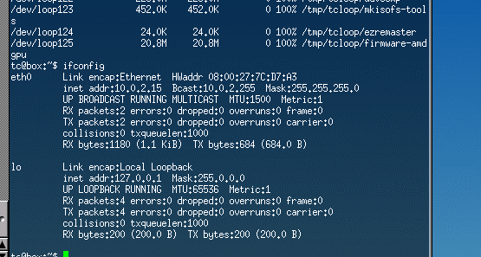
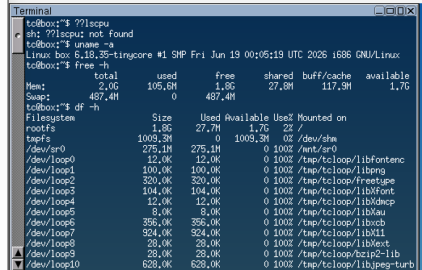

Final Evidence Checklist
Done | Checkpoint | Evidence to Capture
□ | Host readiness verified | Host OS, RAM, storage and virtualization status evidence.
□ | Hypervisor installed | VirtualBox or VMware  installer/source/version and home screen evidence.
□ | OS choice justified | Selected OS, approximate ISO size, source linkand reason for selection.
□ | VM configured | CPU, RAM, disk, disk format/controller and NAT network screenshots.
□ | Guest OS running | Boot/desktop/installer/login proof inside hypervisor window.
□ | Guest verification completed | CPU, RAM, disk and network command evidence.

GP-VM-01 | CSA15 Cloud Computing and Big Data Analytics | Dr C. Rajesh Babu, SSETSCS415
Explain and Extend
Explain why VirtualBox or VMware is suitable as a type-2 hypervisor for this lab.
Oracle VirtualBox is suitable as a Type-2 hypervisor because it runs above the host operating system and provides virtual CPU, RAM, storage and network resources to the guest operating system. It is suitable for this lab because it allows a Linux virtual machine to be created and managed without replacing the Windows host operating system. It is also useful for student laboratory demonstrations because the VM can be started, configured and tested easily.

Explain why your selected OS is appropriate for your laptop and internet constraints.
Tiny Core Linux CorePlus is appropriate because it is a lightweight Linux operating system with a relatively small download size and a graphical desktop environment. It requires fewer system resources and reduces download time compared with larger Linux distributions. Therefore, it is suitable for this laptop and for completing the VM laboratory within the available storage, bandwidth and lab time.

Explain whether your VM configuration matches the standard 1 CPU, 2 GB RAM and 15 GB disk requirement or why you used a justified lightweight alternative.
My VM configuration uses 2 virtual CPUs, 2 GB RAM and a 20 GB VDI virtual disk with NAT networking. The RAM matches the standard 2 GB requirement, while the CPU and disk are slightly higher than the standard 1 CPU and 15 GB configuration. The additional resources were used to provide reliable operation of the Tiny Core Linux guest while remaining within the available host resources.

Extend this setup to your capstone: what component could be tested in this VM?
This VM can be used as a lightweight testing environment for a capstone component. A backend service, API endpoint or supporting Linux-based service could be tested inside the VM before deployment to a cloud environment. The isolated VM environment allows application behaviour, networking and resource usage to be verified without affecting the host system.

Submission Protocol
- Create a GitHub folder named CSA15-GP-VM01-Type2-Hypervisor-VM-Creation.
- Upload this completed document as DOCX/PDF along with screenshots and short README.md.
- README.md must include tool used, VM/cloud specifications, configuration decisions, screenshots index and cleanup status. - Submit the GitHub repository link in Google Classroom. Do not upload passwords, private keys, tokens, public IP credentials or sensitive account screenshots.
Student Assurance
Declaration
I confirm that this guided-project evidence was completed by me, the screenshots are from my own lab environment, and no secret keys, passwords or sensitive account information are included.
Student Signature: K.R.VISHNU CHAITHANYA Register Number: 192372057 Date: 14-08-2026

GP-VM-01 | CSA15 Cloud Computing and Big Data Analytics | Dr C. Rajesh Babu, SSETSCS415

